Prayer on the Frontline:

Direct Action at Standing Rock  
*(Part 2 of a 3-part essay)*

By Nathan Albright

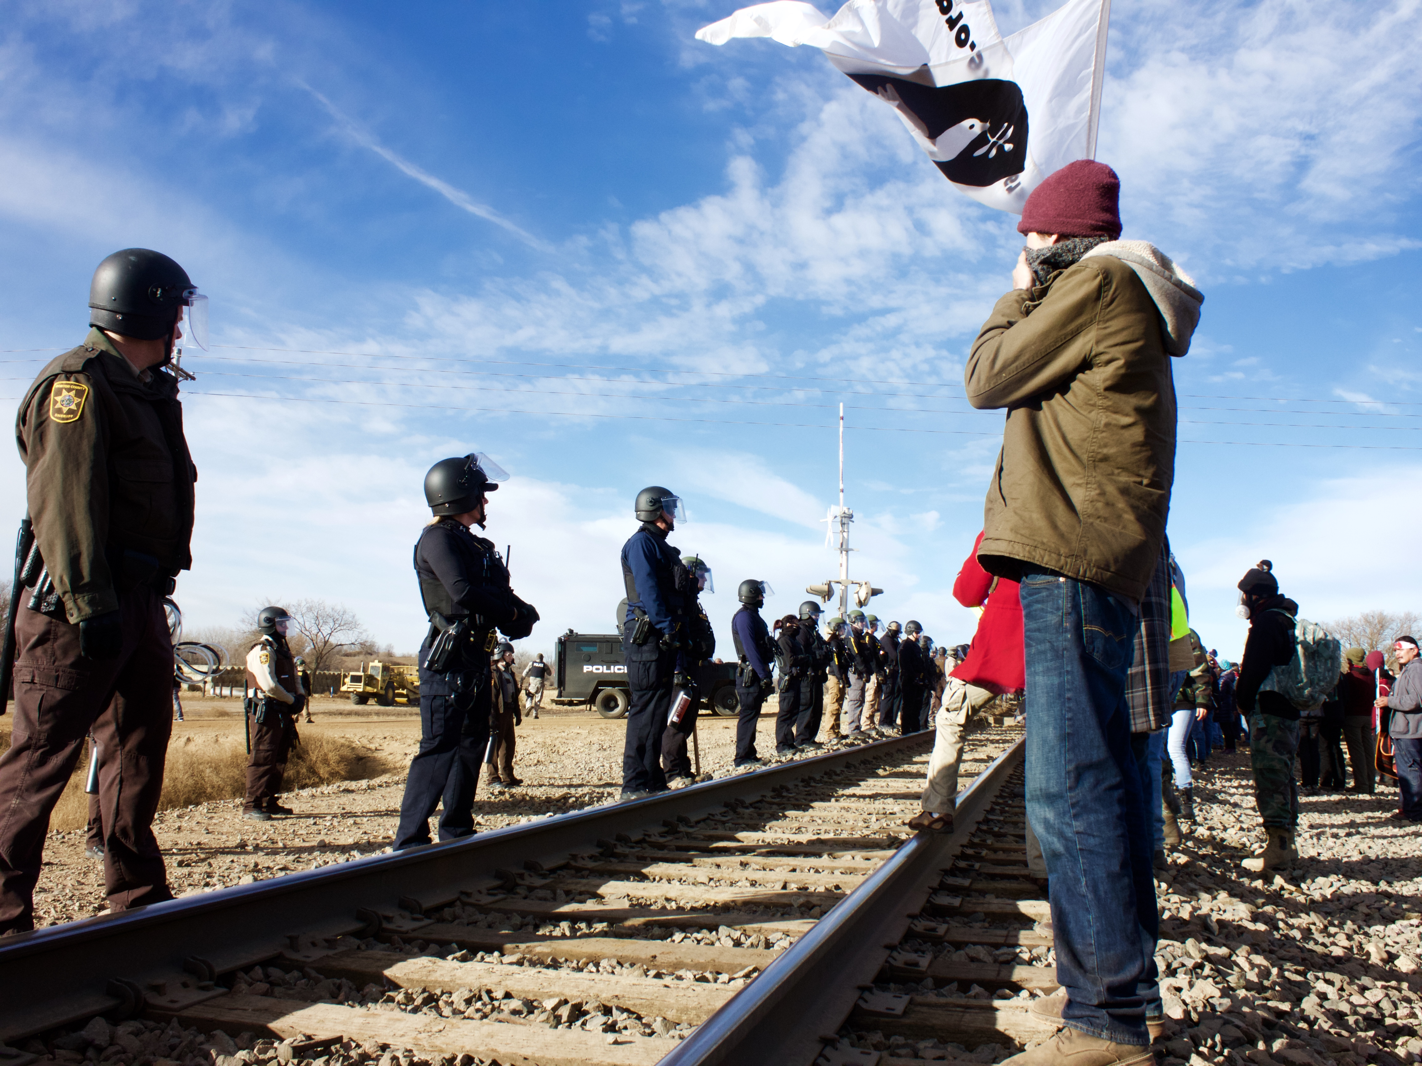

Photo by Elizabeth Culbertson

We stood linked in a chain, about 30 people across, facing three bulldozers that sat on a dirt path directly on top of the Dakota Access Pipeline. Only a day earlier I had driven [LINK part 1] out to Standing Rock with a small group of Catholic Workers from the East Coast. Now we were arm in arm with Indigenous activists and supporters who had caravanned to a construction site just off a local highway, at the bottom of a steep hill. In front of each bulldozer were a handful of angry men, construction workers and security detail for Energy Transfer Partners, warning us not to come closer. “Get the fuck out of here,” said one of them, pointing at us with an aluminum bat. “We’re nonviolent!” shouted someone from our line. “We’re not,” he yelled back. A tense moment of silence followed. Then a native Lakota elder began a prayer and a few others joined in, raising their voices to a beautiful song. A few photographers hurried around the perimeter, trying to find a good vantage point to capture the moment. Suddenly, screeching off the highway, a pickup truck came from behind us, barreling down the hill towards our line. “Mni Wiconi!” cried a voice turning to face the driver, “ water is life!” At the edge of the line, I watched the truck gather speed, my mind spinning, my jaw clenched and my feet stuck to the ground. At the last second, those in the middle moved aside and the truck blew past, fishtailed and skidded to a stop in line with the bulldozers. With hearts pounding, we heard a quiet, calm elder Lakota voice announce, “we don’t want anyone to get hurt today, let’s walk back.”

The day before, immediately upon arriving at camp, we had attended a nonviolence training session, mandatory for anyone thinking about participating in this kind of direct action. Gathered around a whiteboard in the middle of a field at the Oceti Sakowin main camp, we listened with about 150 others as two women, both young, native activists from IP3 (Indigenous People’s Power Project), spoke.

“Please know that once you set foot in this camp, you are stepping into a different space. Be aware that this is all ceremony: walk with respect. This is a place of no drugs, no alcohol, no weapons. This is a sacred place. We are non-homophobic, we respect a gender spectrum, and women are our leaders. Listen to native leadership, and if you are white, if you are an outsider, please allow others to speak first. We are decolonizing this space.”

One of the facilitators read from a list of twelve basic rules for new members. “Rule number one: we are protectors, not protestors. Rule number two: we are peaceful and prayerful…” They went on to outline rules for a community genuinely concerned with giving voice to the voiceless, with creating a space that felt safe and welcoming to all. The conversation then pivoted from the community’s insistence on nonviolence to the very real violence that it faced. “Please do not wear contacts to the actions. They can cause serious permanent damage to your corneas when reacting with pepper spray. Be aware that Law Enforcement will likely be carrying pepper spray as well as tear gas, and a few people have been injured by shrapnel from stun grenades. At many of the actions we’ve also seen large armored vehicles equipped with sonar guns. You will want to bring bandanas, goggles, and possibly earplugs.”

Staring down these tools of violence from the state, in an era when no group of people in the US is killed by police in greater proportion than Native Americans, and in the shadow of a history of so much specific regional brutality from the government, native leadership consistently and calmly spoke of commitment to nonviolence.

I was amazed that this group of people who, as much or more than any other in history, would be justified in despair, instead showed a remarkable lack of cynicism. The only way to make sense of this paradox was through a transcendent, even spiritual logic. This sense of spirituality was central to the movement at Standing Rock. Prayer was completely integrated into daily life. Whether at camp or on the frontlines, everything was suffused with the spiritual and grounded in ceremony. And nowhere was this clearer than in the nonviolent response to state violence. This was spirituality in motion. Every direct action planned was a public prayer and an invitation to hope. Native leaders were calling for an end to the pipeline, but they were also calling for spiritual renewal and social transformation. And it was reflected in the atmosphere surrounding us. From the moment we arrived at camp, neighbors and people just walking by came to help assemble our tent, offered to show us around and took an interest in our well-being. The generosity and hospitality was overwhelming. A sense of hope was alive and flowing through the camp. Walking back to our tent at the end of that first day, while reflecting on all I’d seen, I passed a large banner hanging near the entrance of camp that read “No Spiritual Surrender.”

~~~~~~~~~~~~

Two days later, the morning after the standoff at the pipeline, I woke up to the sound of hoofs against hard clay. A rider called out from his horse, “wake up and pray! You’re here for a reason, it’s time to greet the sun!” Stepping out of our tent and into the morning, I saw a crowd headed to a water ceremony down by the river while a member of our group returned from the center of camp with details on the day’s direct action. Within the hour we were piled into our car and lined up with other cars at the camp’s south gate. The caravan pulled out onto the road and began the drive, snaking through the low hills and sweeping plains of the reservation. Hovering above the lead car was a familiar bright yellow surveillance helicopter.   
 The direct action we were headed to that day was inspired in part by a report that Amnesty International had just put out called “Out of Sight, Out of Mind,” [LINK http://www.amnesty.ca/outofsight] which “links the effects of intensive resource development to the heightened levels of violence against Indigenous women and girls.” The Amnesty case study was specific to British Columbia, but the same had been occurring at Standing Rock ever since the oil companies had moved in. The plan for the day was to travel to one of the construction camps and say a prayer for all the women and girls who had been violated, abused, or disappeared in connection with workers from the oil companies. Recognizing this phenomenon made abundantly clear the links that Native Leadership had been making between racial, sexual, and environmental justice: that one cannot exist without the others.

Before the caravan reached the oil workers’ camp, a squad of police cars, probably informed by the surveillance helicopter, cut us off at a railroad crossing. Cars from the caravan pulled over and parked all along the side of the road at the bottom of a hill, beneath the tracks. People of all ages carrying signs and artwork, bandanas and goggles, led by young Native women, climbed out of their vehicles and walked up the hill as far as they could. In a moment the railroad tracks were the only thing separating a long line of Water Protectors from a long line of armed police officers and militarized vehicles. Once it was clear that we would not be let through, the organizers decided to proceed with the prayer as planned, and invited women, especially mothers and elders, to circle together and join.

To the left of the main circle, I knelt in prayer as part of the line facing the police. Over my shoulder, I could hear a voice that I recognized, singing. It was a young Cherokee woman we had met the day before, named Olive. She had come from West Virginia, where her mother had contracted a terminal illness from poisoned water. For her, as for many others who had traveled from reservations around the US where water is contaminated by toxic industrial projects, the rallying cry “Water is Life” was deeply personal. She had been trained as a Sun Dancer by a Cherokee elder in the Southeast and had come to Standing Rock to bring Sun Songs to the frontlines.

I looked up at the officers across from me. Most were avoiding eye contact, with their face shields down staring straight ahead, waiting for orders. Behind the main line of police was a second line of officers who were carrying industrial-sized canisters of pepper spray. Behind them was a large armored truck equipped with a sonar gun. As we faced this line of police, young Native leaders walked back and forth along the line encouraging us. “Look up, have love in your eyes… these are not our enemies.”

As the women who were circled behind us began to say a prayer, the armored truck turned on its loudspeakers and began blasting an announcement: “You are blocking a public highway. You are all subject to arrest. Return to your vehicles immediately.” The women tried to continue the song and prayers of the ceremony, but the announcement, repeating on a loop, was drowning everything else out. Many bowed their heads and continued to pray in silence. I closed my eyes and joined them. Suddenly a great chorus of cheers rose up around us. I opened my eyes and saw that everyone was looking straight up, Water Protectors on all sides reached for the sky and called out with cries of celebration. Even the officers who had held steely glares since we arrived seemed genuinely startled for a moment and looked up.

Directly above us flying in low circles around the sun, was an eagle. I watched it wheeling around the sky, felt the effervescence of the moment as the sounds of the loudspeakers faded out, as the cries of jubilation blended into a single note. I stared directly at the sun, and then time stopped.

I felt a sense of clarity, that there is no other world. No more a distant heaven than a hidden cyberspace, no mind, no soul, no past, no future, no elsewhere, no other realm into which I can retreat from my senses, no division between me and this stunning, beautiful, vibrant, living world. I felt my small place in the grand and incomprehensible web of life, the expanding landscape and the elaborate microscopic universe that exists within every creature. There I was, fully returned to my senses – where had I been before? The blue of the sky, the brilliance of the sun.

I praised what my senses took in. This act is, after all, the origin of spiritual practice, the foundation of all religion—oral traditions praising the earth that brings forth life. Wild, intricate, unfathomable, delicate and irreplaceable. If this is not sacred, what is?

I thought of Ladonna Bravebull Allard, the founder of Sacred Stone, the first DAPL resistance camp at Standing Rock, and how she spoke of the destruction of the landscape as something intimately felt. “The U.S. government is wiping out our most important cultural and spiritual areas. And as it erases our footprint from the world, it erases us as a people. These sites must be protected, or our world will end, it is that simple… We are the river, and the river is us. We have no choice but to stand up.” This was why we had come, to protect this land and support those who know and love it best, whose beliefs have been historically belittled and disregarded. We came to learn about this connection to the land, and to begin a healing process for those of us who have become alienated from the earth. We came to snap back into our senses and recognize the crisis we face, the tragedy we participate in, the coming catastrophe we have brought upon our only home.

When you stare at the sun, you have no other option than to tear up. And what choice did I have now? I felt my own role in the desecration of my home, the wild, precious world that gave me life. On all sides, artwork and signs read “Defend the sacred,” and “Water is life.” The deeper meanings of these mantras washed over me in waves. I was moved by the beauty and simplicity of this message. We have a duty to throw ourselves in the way to protect what is alive and endangered, irreplaceable and quickly disappearing. How else should we react to the destruction of our home, the source of all life?

I felt that nothing could move me from where I stood. And then the call came, again from a quiet calm voice, to walk back to our cars and leave, to obey the loudspeakers and go home. “We’ve done what we came to do.”

We linked arms and started to move backward. Although the organizers had decided to pull everyone back, as soon as the crowd began to retreat, officers crossed over the railroad tracks to advance. In a matter of seconds police were on us, wedging nightsticks under our shoulders, pushing us back and pulling people off the ends of the line to make arrests. We kept our arms locked together and walked slowly backward down the hill, concerned for the elderly and less-able members of the group behind us. As we tried to hold together against the pressure from the police, the rear line of officers stepped forward and began indiscriminately spraying the crowd with pepper spray. Our line fell apart and pandemonium broke out. People on all sides were covered in pepper spray, screaming, trying to help one another, and climbing into idling vehicles. In the confusion, our group somehow found each other and made it safely back to our car. Olive, separated from her ride, recognized us from the day before and got in with us.

We tried to clear out as officers had demanded, but once we pulled onto the road we realized that the police were preventing anyone from leaving. Officers, dressed in swat uniforms walked down the line of cars, checking in windows and looking for organizers. Directly in front of us, following the day’s nonviolent prayer ceremony meant to honor disappeared and violated native women, we watched ten large all-white, all-male, police officers, many covering their faces with balaclavas, pull a young native woman from her car and arrest her. About 20 minutes later, the police opened the road and let us go.

On the drive back we cleared pepper spray from our faces and checked on each other, trying to process what had happened. I was in the middle of the car, with Olive to my right, looking out the window. As a heavy silence set in, she began to sing another Sun Song, quietly to herself. We were packed together so tightly that I could feel each breath she took in and the weight of sadness in her voice. Later, when asked what she was singing, she said “a song of hopeful persistence.”

~~~~~~~~~~~~

When we got back to camp we were all in a haze. The beauty of the moment at the railroad tracks, the violence it gave way to so quickly, the powerlessness as we watched others taken away by the police. I looked out from our tent and saw a neighbor standing by his camper. Not quite sure what I was doing, I wandered over and introduced myself. John Dreher, part Crow from Terrahote, Indiana, had picked up his best friend Dean Dempsey, a Navajo living in Danville, Illinois, and the two of them had come together to support the Lakota. Before I could say a word, I was handed a bowl of stew and told to join them.

I told them about the days events and they told me why they’d come to Standing Rock. “There’s hundreds of miles between his people’s homeland and mine,” said John, “but the story is the same.” Dean agreed, “Every indigenous person understands and feels what’s going on here because it has happened to them.” He went on, “I was born and raised on a Navajo reservation and I heard about a big corporation coming in and wanting to mine a mountain, Black Mesa… The mining company came in and forced everybody off and kept digging that mountain, looking for coal. The elders fought that and lost. Every ton of coal they took out of that mountain, we got a nickel. They left piles, in little mountains all over the place. Nobody knew that they were toxic, how bad it was for everybody. As kids we played on it too.”

John shared a similar story, “now back home where I grew up in Illinois, we have those slag piles from the coal mine like he’s talking about and I saw the waste and what it did, dead waters that nothing could live in. There was a zinc smelter near our town, near a piece of land there, that’s permanently destroyed because the Hegeler Zinc people contaminated it. That was years ago, that company was closed before I was even born, but the land is still poisoned. One goof up, one welder, one engineer makes a mistake [on this pipeline] and generations can be impacted.”

I asked them how it felt to see the camps forming at Standing Rock. Dean smiled, “The spirit of the Lakota and of the people here is really uplifting, it excites my heart. Maybe *this* time, maybe *this* time they’ll listen… The pride I feel seeing all these teepees up, and all these songs and all the prayers. You know a lot of young people have lost a lot of their language and a lot of their cultural knowledge but just seeing them riding around and being in this camp is exhilarating because they’re getting a taste of it, and I hope that’s going to bring them back, to encourage them to learn their language and to learn their culture. My son’s one and a half and my daughter’s four, and I explained to them [when I left]… I said I’m going to go pray with these people and try to help them in some way.”

I asked Dean about the prayers he says. “Navajo prayer starts with God, mother earth, the four directions, all the way around you, and then I pray for safety for my family and my kids and that God blesses us… I really hope they stop this pipeline. Right now the main issue is this water and the life of this community and the life of this land and the life of all the animals and the fish that run down this water and all the people that this water affects. There are many families down this river that drink this water and these prayers are also for them.”

As we watched the sunset over the river, I thought about the prayer at the railroad tracks, I wondered what the next few days would bring, I thought about how strange it would feel to be back in New York in a little over a week. I asked one last question, “What message should I bring home with me?”

John answered first, “we talked about these historic stories about coal, uranium, you know now its oil, now its whatever—I would encourage everyone to stop and pause a minute and think—probably the finest thing that Jesus of Nazareth ever said, out of all the great things, he said ‘whatsoever you do even unto the least of these my brother, you’ve done it unto me.’” We paused and let his words sink in. Dean said, “That’s a good one.” John said, “It’s the only one.”

Then Dean gave his answer: “Understanding, empathy. Tap into your heart and your spirituality. And you may have a glimpse of our daily life. Right now all we’ve got is prayer. And that might be the only thing we need.”

*Nathan Albright is a Cofounding Editor at The Flood.*

[LINK Parts 1 & 3]